**Office 365 CLI Overview**

Office 365 CLI is an open-source project from PnP (Pattern and Practices). It helps to manage Office 365 tenant and SPFx projects on any platform (including Windows, Linux, macOS, etc.). Office 365 CLI is available as a distributable NPM package. Use the below command to install Office 365 CLI.

1. npm i -g @pnp/office365-cli

**Upgrade SPFx Solution to Newer Version**

We will take an example of SPFx solution developed earlier with SPFx drop version of 1.8.2. we will upgrade this solution to the latest SPFx version 1.12.1

Follow the below steps to upgrade the SPFx solution to the latest version.

**Step 1**

Open the command prompt.

**Step 2**

Execute the below command to update the Office 365 CLI to the latest version.

1. npm install -g @pnp/office365-cli@latest

**Step 3**

On the command prompt, navigate to the SPFx solution directory and execute the below command.

1. o365 spfx project upgrade --output md > report.md

This will generate a markdown file with the list of changes to be applied to SPFx solution to upgrade it to the latest version. Please note that Office 365 CLI does not apply any changes to SPFx solution. The changes need to be applied manually.

**Step 4**

On the command prompt, type the below command to open the SPFx solution in the code editor of your choice (e.g. Visual Studio Code).

1. code .

**Step 5**

Open report.md file in Visual Studio Code.

**Step 6**

Click “Open Preview to the Side” to open markdown file in a preview mode.

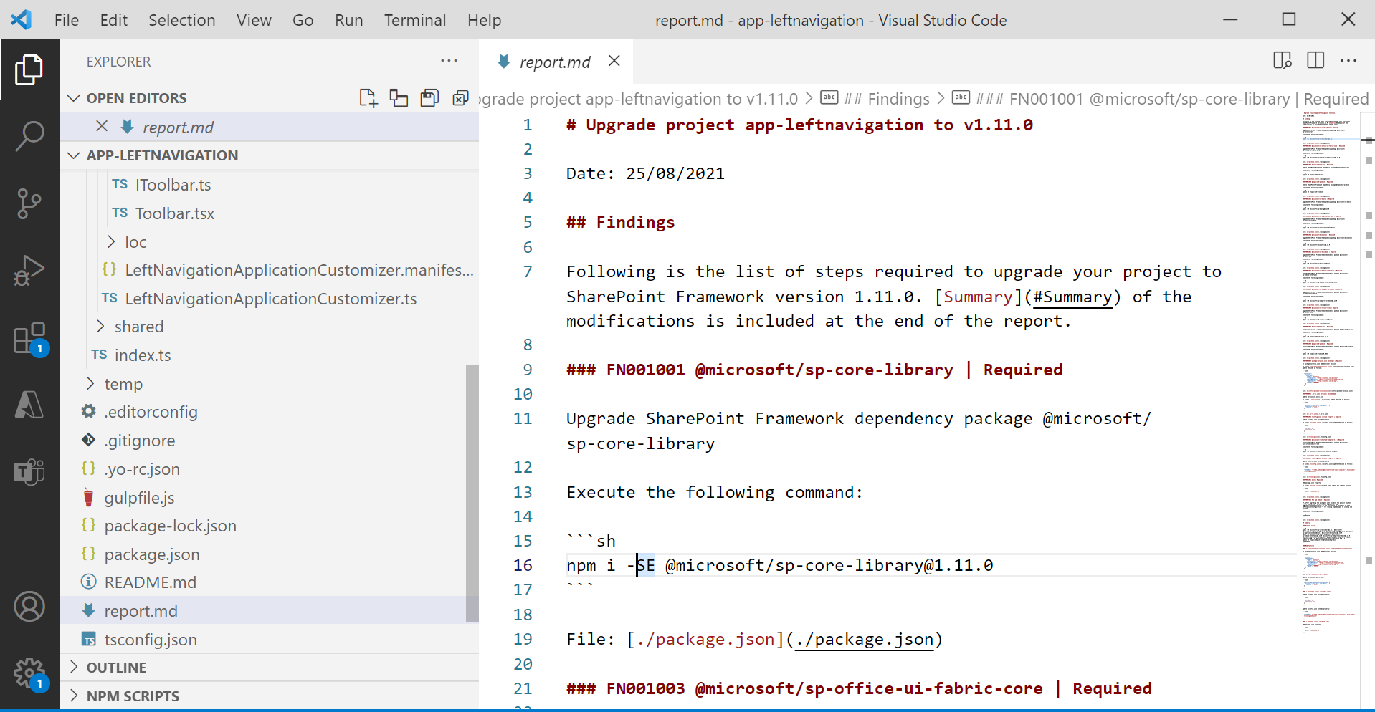

**Step 7**

The markdown file will open in a preview mode with easy-to-follow instructions.

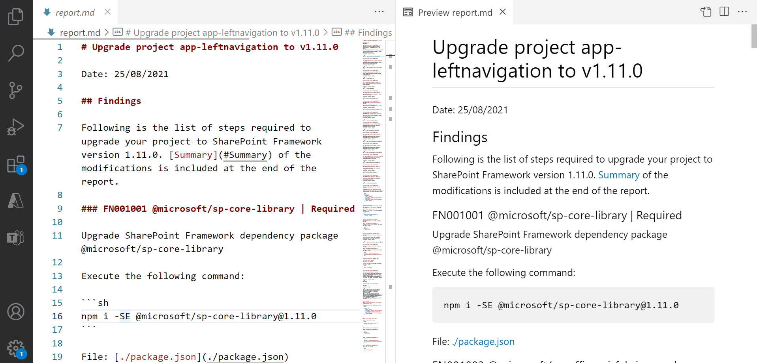

**Upgrade SPFx Solution to Specific Version**

In some scenarios, we might not want to upgrade to the latest available SPFx version but maybe to some intermediate version. Office 365 CLI supports this scenario. Use below command to upgrade to any specific version

1. o365 spfx project upgrade --toVersion 1.12.1 --output md > report.md

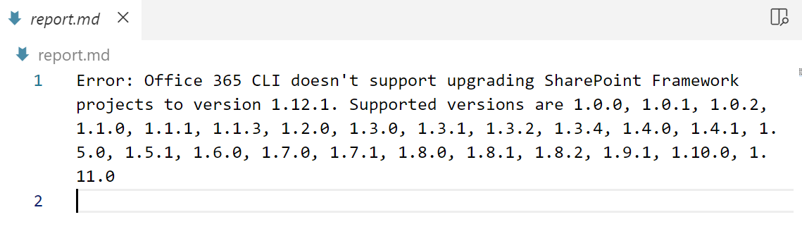

Office 365 CLI does not allow upgrading the SPFx **1.12.1** solution

**Downgrade SPFx Solution?**

No, Office 365 CLI does not allow downgrading the SPFx solution. For example, if your SPFx solution is created using version 1.7.1 then running below command will not downgrade the SPFx solution to 1.5.0.

1. o365 spfx project upgrade --toVersion 1.5.0 --output md > report.md

The report will show the message “Error: You cannot downgrade a project”.

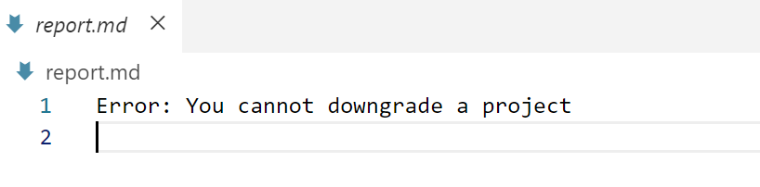

**Upgrade SPFx Solution to 1.12.1**

**First uninstall Office 365 CLI**

npm uninstall -g @pnp/office365-cli

Then you need to install CLI for Microsoft 365 using npm by executing the following command:

npm install -g @pnp/cli-microsoft365

If you already have CLI for Microsoft 365 installed on your machine, you can simply update to the latest version:

npm install -g @pnp/cli-microsoft365@latest

When it’s done, you can open an existing SPFx project to upgrade with Visual Studio Code and execute the following command:

m365 spfx project upgrade --toVersion 1.12.1 --output md > "project-upgrade.md"

This command generates a markdown file named project-upgrade.md inside your project with all the required steps to upgrade your project to the latest version of SPFx (1.12.1).

